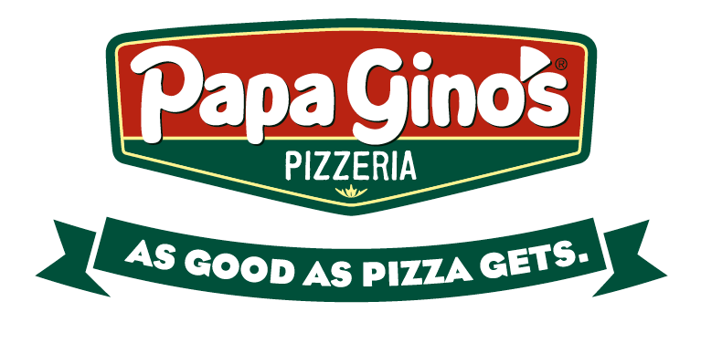

Papa Gino’s
Community Fundraiser to Benefit the
Jeremiah’s Inn
We will earn 20% of the Sales from our
Families & Friends during this time!

Be sure to submit this certificate when ordering.
Valid on Dine-In, Carry-out and Delivery!

When: Thursday, April 26, 2018
Time: 4:00 P.M. - 9:00 P.M.
Where: 1241 Main Street, Worcester
Phone: 508-753-9340

- This flyer must be presented, or shown on a mobile device, to the cashier or delivery driver in order for your organization to get credit for your order.
- Online orders enter code 19 at the payment screen and click apply.
- Fundraiser orders are only valid with regular priced menu items and cannot be paired with coupons or deals.
- Papa Gino’s will donate 20% of the total pre-tax sales from all the guests that present your flyer during the fundraiser.
- Flyers cannot be handed out in or around the Papa Gino’s restaurant on the day of your event.
- Flyers made by the organization will not be accepted for the fundraiser event.
- RESTAURANT ONLY - Ring this sale using the POS button 19: Fundraiser.

